**Design principles & Pattern**

**Exercise 1: Implementing the Singleton Pattern**

**Program.cs**

**using System;**

**class Program**

**{**

**static void Main(string[] args)**

**{**

**Logger logger1 = Logger.GetInstance();**

**logger1.Log("This is the first log message");**

**Logger logger2 = Logger.GetInstance();**

**logger2.Log("This is the second log message")**

**logger2.Log("This is the second log message")**

**Console.WriteLine("Are both instances same? " + (logger1 == logger2));**

**}**

**}**

**Logger.cs**

**using System;**

**public class Logger**

**{**

**private static Logger instance;**

**private static readonly object lockObj = new object();**

**private Logger()**

**{**

**Console.WriteLine("Logger created");**

**}**

**public static Logger GetInstance()**

**{**

**if (instance == null)**

**{**

**lock (lockObj)**

**{**

**if (instance == null)**

**{**

**instance = new Logger();**

**}**

**}**

**}**

**return instance;**

**}**

**public void Log(string message)**

**{**

**Console.WriteLine("Log: " + message);**

**}**

**}**

**OUTPUT:-**

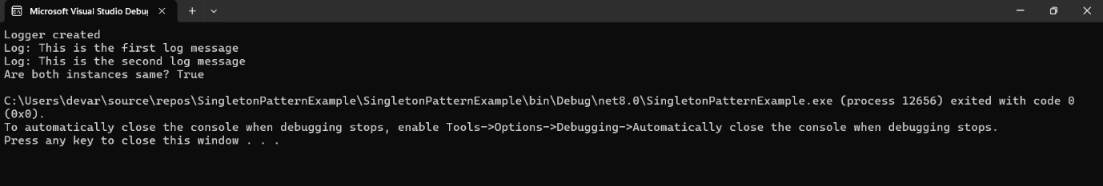

**Exercise 2: Implementing the Factory Method Pattern**

**Program.cs :-**

**using System;**

**class Program**

**{**

**static void Main(string[] args)**

**{**

**DocumentFactory factory;**

**factory = new WordFactory();**

**IDocument word = factory.CreateDocument();**

**word.Open();**

**factory = new PdfFactory();**

**IDocument pdf = factory.CreateDocument();**

**pdf.Open();**

**factory = new ExcelFactory();**

**IDocument excel = factory.CreateDocument();**

**excel.Open();**

**}**

**}**

**WordDocument.cs:-**

**public class WordDocument : IDocument**

**{**

**public void Open()**

**{**

**Console.WriteLine("Opening Word Document...");**

**}**

**}**

**WordFactory.cs :-**

**public class WordFactory : DocumentFactory**

**{**

**public override IDocument CreateDocument()**

**{**

**return new WordDocument();**

**}**

**}**

**PdfDocument.cs :-**

**public class PdfDocument : IDocument**

**{**

**public void Open()**

**{**

**Console.WriteLine("Opening PDF Document...");**

**}**

**}**

**PdfFactory.cs :-**

**public class PdfFactory : DocumentFactory**

**{**

**public override IDocument CreateDocument()**

**{**

**return new PdfDocument();**

**}**

**}**

**ExcelDocument.cs :-**

**public class ExcelDocument : IDocument**

**{**

**public void Open()**

**{**

**Console.WriteLine("Opening Excel Document...");**

**}**

**}**

**ExcelFactory.cs :-**

**public class ExcelFactory : DocumentFactory**

**{**

**public override IDocument CreateDocument()**

**{**

**return new ExcelDocument();**

**}**

**}**

**DocumentFactory.cs :-**

**public abstract class DocumentFactory**

**{**

**public abstract IDocument CreateDocument();**

**}**

**IDocument.cs**

**public interface IDocument**

**{**

**void Open();**

**}**

**Output:-**

